March 2017 Newsletter – Institute of Grace
Upcoming: March 18 at 7 PM Fundraiser at First Alliance Church (14500 New Hampshire Ave., Silver Spring, MD). Desserts and a chance to hear about our plans for this year and next. Bring a friend.
The University de la Grace is in operation again!
I (David Graves) taught Session One of our Church Leader training program, complete with a 44-page handout in French. I had 14-17 in class each day and worked with my favorite translator, Jr. Desir. It was a joy to get to know the students better over several hours of interaction each of seven days. It is inspiring how motivated these men and women are to learn and improve. I’m looking forward to Session Two in April. This is the first semester of the University’s operation since the school was shut down following the earthquake in 2010. We have been praying and working toward this for years. With this first group, tuition support is greatly needed.
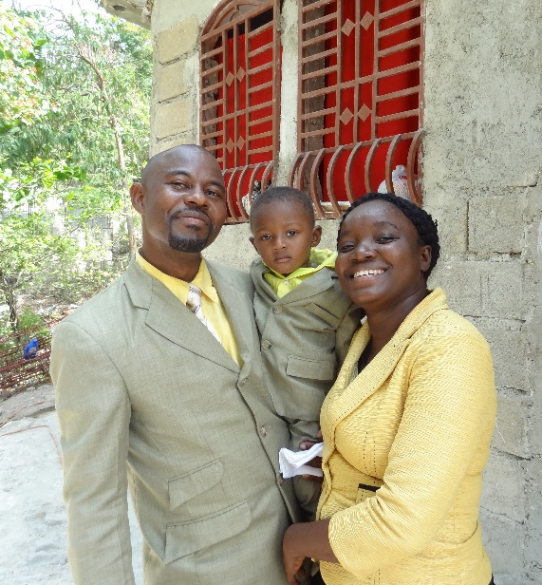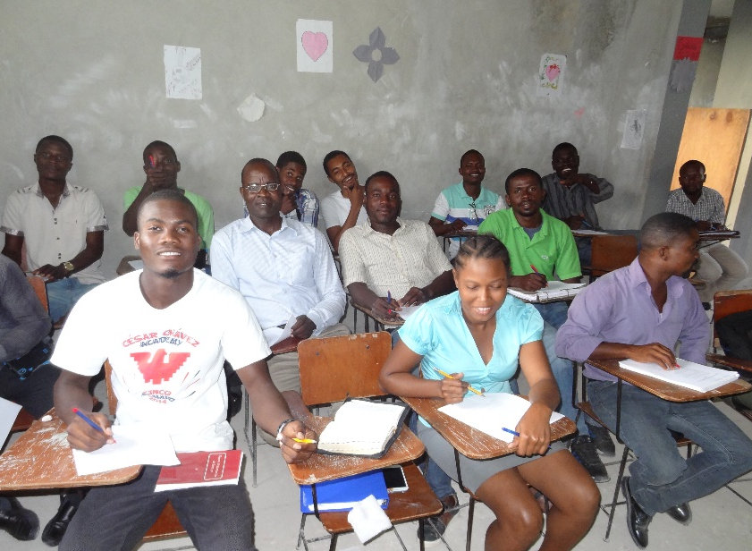
Student Advisor Pastor Amorse with family. The University students in class.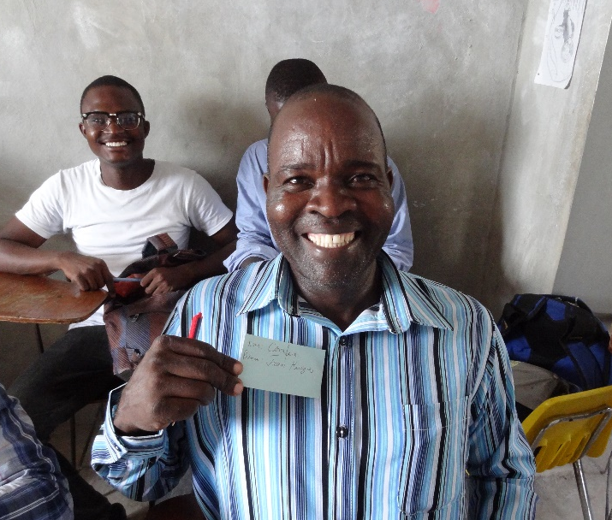
One of our best students, Hughues. Four students (David, Guerdine, Me, Alsine and Hughues) with me at church Sunday.
EGF Primary School hands out backpacks and school supplies from Alpha Kappa Alpha!
Madams Rosalyn and Bersey handed out backpacks and school supplies to the students in each class room. These supplies arrived in January on the Isuzu Box Truck and were donated by the Iota Lambda Omega Chapter of Howard County of Alpha Kappa Alpha Sorority, Inc. We are excited to see their interest in the school and hope to take advantage of their expertise as we continue to work on expanding and improving education opportunities in Merger. I also got to hear rousing renditions of the weekly Bible verse from various classes.

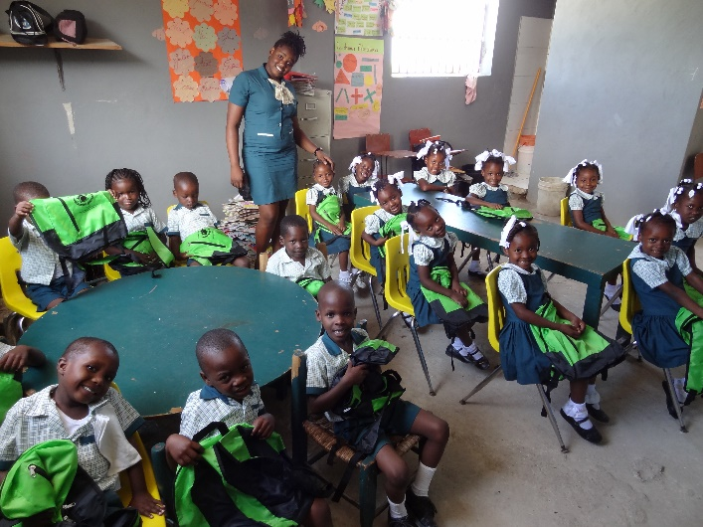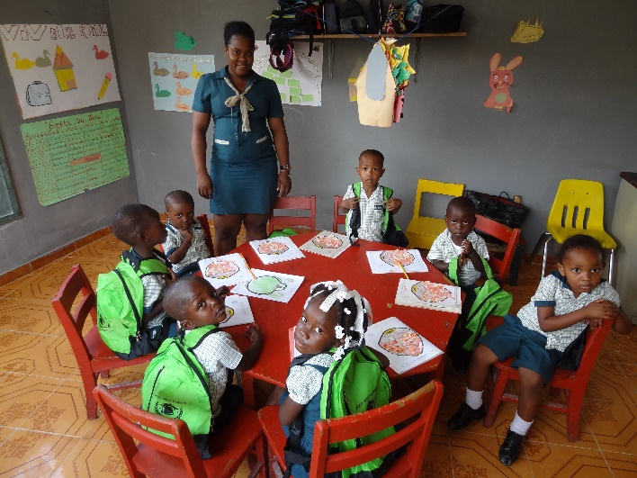
Kindergarten with M. Sheeneidine. Pre-K (3 yr. old) with M. Nicole.

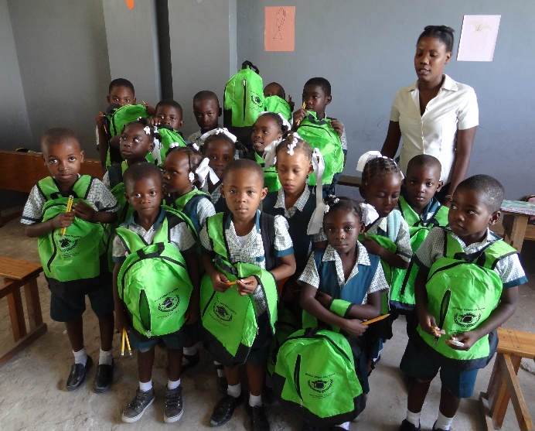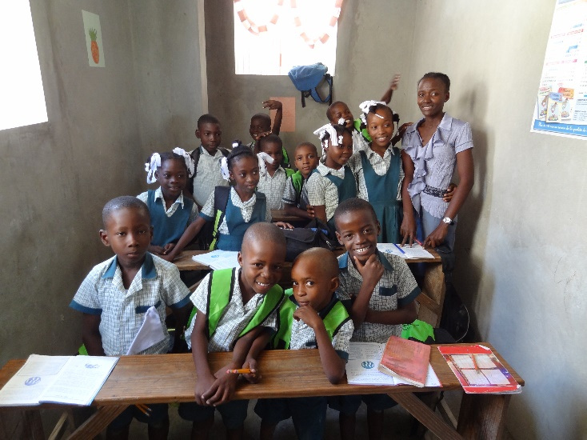
First Grade with M. Miranda Second Grade class with M. Tania.

Major work on the exterior of the third floor of the main building.
I got to watch a large crew pour a roof at the Guest House and exterior work on scaffolding on the third floor of the original building on the site. These men work so hard all day long under conditions that make the average person shudder. The scaffolding is 2X4s nailed together with plywood set across for the platform.
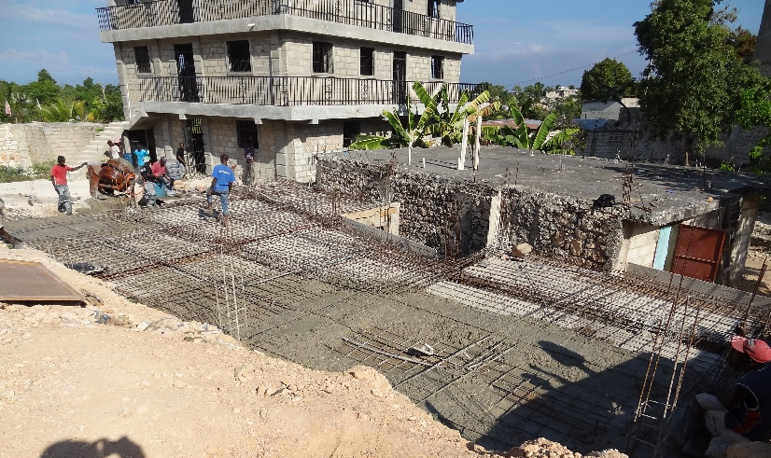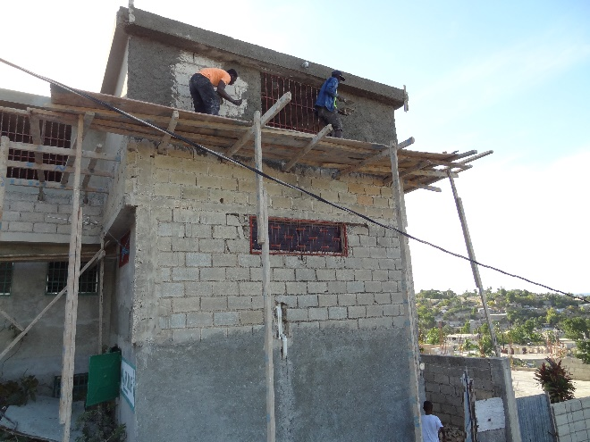
Pouring a roof by the Guest House in background. Securing the third floor of main building.

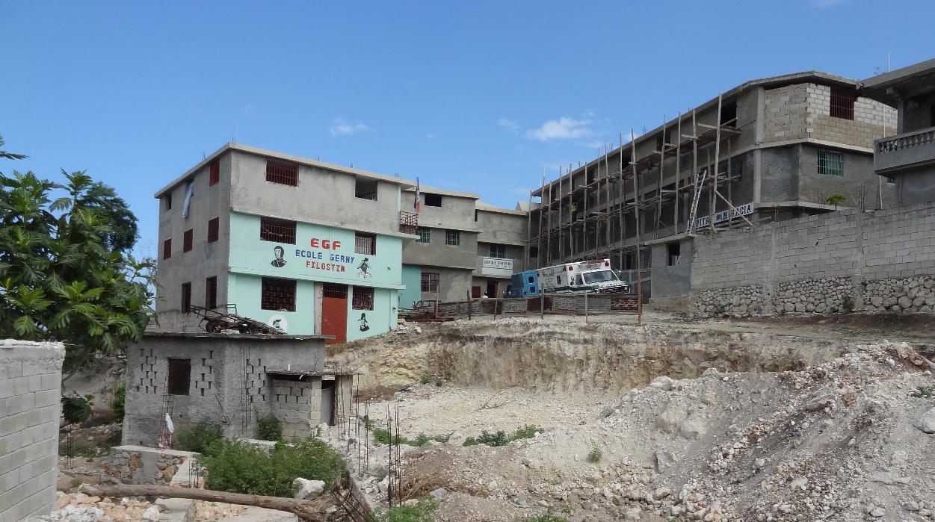
More scaffolding and a view of the Primary School (also being used by the University until we get the first floor of the Guest House ready for the University de la Grace classrooms and offices.

Gathering and Fundraiser March 18 at 7 PM
We will share pictures and stories and seek to raise support for the work of the IOG. We will gather at First Alliance Church (14500 New Hampshire Ave., Silver Spring, MD), share desserts, and I will offer some reflections and pictures of my Feb trip and the work ahead of us.
Upcoming trips:
I will be returning to Haiti several times this year and I would be glad to have company. Individuals and groups are welcome and date ranges are flexible. Projects range from roof top gardening and solar panels to working with young children and University students. Merger is a difficult environment as vacations go, but the experience is lifechanging both for us and for them. Please contact me if you are interested in going or supporting one of the IOG projects.
Current dates on the calendar: April 18-26; May 23-29; June 21-28 with Church of the Redeemer UMC in Temple Hills, MD; September 12-20 with Silver Spring UMC in Silver Spring, MD; and November 7-16. I am especially looking for pastors to help with the church leader training program.

If you would like to support the Church Leader Training, or any other aspect of the IOG, we welcome your support. Contributions can be mailed to: [we also have an online giving option on the IOG website]
Institute of Grace [InstituteofGrace.org]
P.O. Box 2364
Leesburg, VA 20176

God is active in Merger, Haiti! I see it on every visit.

David Graves
March 10, 2017

